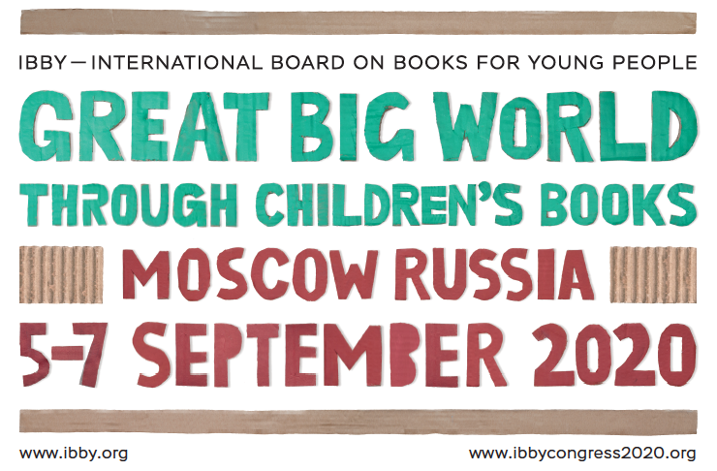

congress TOPICS
The theme of the International Congress in Moscow 2020 is «Great Big World Through Children’s Books: National and Foreign Literature — Role, Value, Impact on Young Readers in Different Countries». It gives us an opportunity to explore diversity of themes, characters, issues in children’s literature of the world, to discuss cultural variety which doesn’t prevent them from interweaving and interacting.
From the theme, we have derived nine sub-themes which are supposed to be aligned with the nine parallel sessions that will be conducted throughout all of the three days of the Congress (names could be changed during the forming of the final programme). Further, each of the sub-theme consists of several topics that are to serve you as reference points in pondering on the theme of your paper or poster.
We encourage you to submit abstracts (250 words max. for abstracts in English, 300 words max for abstracts in Russian) in keeping with the suggested topics you can find by clicking the link below.
https://ibbycongress2020.org/en/congress/topics-en
(Note: To submit your abstract, please, visit your profile on this website by logging in and clicking on the menu item 'Registration'. If you have not signed up yet, please, press a Sign up button on the top of the page to create an account where you will be able to add all information essential for participating in the Congress as a speaker or as a listener.)

CALL FOR PRESENTATIONS
The Organising Committee for the IBBY Congress 2020 invites you to submit abstracts for individual presentations and posters.
- Individual presentations (20 minutes) will be grouped in parallel sessions of one and a half hours total.
- Posters will be on display for one-hour sessions within the program. Presenters will be required to be beside their poster during these sessions. We recommend to leave the posters on the poster boards after the sessions till the end of the Congress.
- Abstracts for presentations and posters submitted to the each of 9 sections (1) Sociology, anthropology and psychology of children's reading; 2) Popular books for children and their parents. What do children choose and what do parents choose?; 3) How to tell stories; 4) The modern world and the world of the future. Non-fiction literature for children; 5) The visual world of children's books; 6) Ethnic culture and multilingualism. Children's literature in national languages; 7) Project activities to promote reading among children and adolescents; 8) Literary translation of children's literature; 9) History of children's literature. Children's literary criticism) will be blind peer-reviewed by the curators of the sections and should address the conference general theme and one of the conference sub-themes.
- Abstracts should be no more than 250 words in length in English or 300 words length in Russian (not including reference list) and have titles of no more than 15 words. Please indicate whether your abstract is for a poster or a presentation by choosing [POSTER] or [PRESENTATION].
Please note that in case of receiving a big number of good quality proposals, the programme committee retains the right to change the type of your proposals from Presentation to Poster or from Poster to Presentation. You will be informed about the changes by email.
Notification of acceptance will be sent by 27 January 2020.
If accepted, presenters (for both posters and individual presentations) must register, and pay the registration fee by 10 April 2020 in order to guarantee inclusion in the programme. Presenters will be responsible for arranging their own registration, transport and accommodation. Suggestions for suitable accommodation will be made on the website of the Congress 2020.

GUIDELINES FOR ABSTRACTS FOR INDIVIDUAL PRESENTATIONS
Individual presentations or posters may be about a research study, a programme or an initiative.
If the abstract relates to research, it should situate the research in the existing literature, indicate the focus or research question(s), briefly describe a methodology and summarise findings and implications. (NB. Your reference list will not be included in the 250-word limit.)
If the abstract relates to a programme or initiative, it should provide an overview of the purpose and participants, development, implementation and outcomes.
GUIDELINES FOR POSTER DESIGN
Your poster should be no larger than A1: 594 x 841 mm (portrait orientation only please). If your poster describes a research study, it should situate the research in the existing literature, indicate the focus or research question(s), describe a methodology and summarise and discuss findings and implications. If your poster describes a programme or initiative, provide an overview of the purpose, participants, development, implementation and outcomes. You should use graphics, tables or other relevant visuals to illustrate the main points; use colour if possible. Have a clear focus and be well organised in order to guide the reader through the poster. Keep it simple, both in terms of the language and visuals used. Choose a readable font large enough to be read from about 1m away (titles/main headings from about 2m distance). Include the title, your name, country and organisation in the display
You may wish to prepare a handout, which can be distributed to interested participants and which you can afterwards leave near the poster.
Further remarks considering the preparation of posters and presentations will be given within several months before the Congress, when the Congress’s preliminary programme is ready.
IMPORTANT DATES
01/08/2019 Registration/Abstract submission opens
01/09/2019 Fee payment begins
23/12/2019 Abstract submission deadline
27/01/2020 Notification of acceptance
30/03/2020 Early Bird deadline
10/04/2020 Presenter registration deadline

Moscow, 26.8.2019

